University Challenge Seed Fund (UCSF)

Discoveries and inventions frequently require financial support for further development prior to seeking commercial investment. The University of Oxford provides translational funds for this purpose, through Oxford University Innovation (“OUI”).
Oxford University Innovation manages the UK’s longest-running continuous proof-of-concept fund: the University Challenge Seed Fund (“UCSF”). Established in 1999, the UCSF aims to accelerate the commercialisation of scientific and engineering research outcomes from the UK’s research base through overcoming the classic “valley of death” encountered by early-stage businesses seeking equity finance.
The UCSF was originally launched with £3.85m in backing from the UK Government, the Wellcome Trust, the Gatsby Foundation, and the University of Oxford. In 2010, the Oxford Invention Fund (“OIF”), a £1.5m alumni-supported initiative, was launched to support innovation across all four academic divisions. Given its shared mission with the UCSF, the two funds merged in December 2018 under the UCSF name. A year later, the University partnered with Oxford Science Enterprises (“OSE”), which committed £5m to the fund, alongside £1.5m of UCSF capital. Under this agreement, OSE continues to co-fund projects at a 3:1 ratio and holds a seat on the UCSF committee.
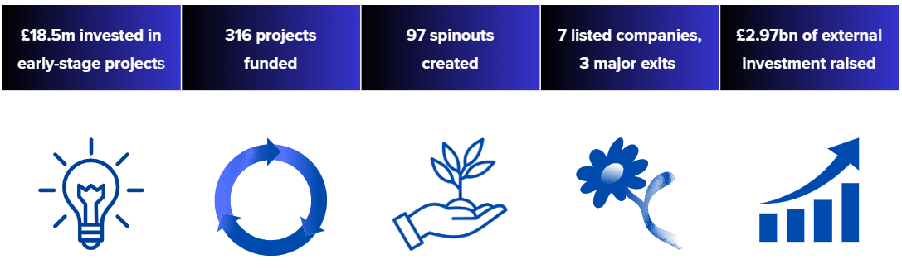
Over the past 25 years, the fund has invested £18.5m in 316 early-stage projects, resulting in the creation of 97 spinout companies – accounting for 40% of Oxford’s total spinouts (248) during that period. Collectively, these UCSF-backed ventures have attracted £2.97bn in external investment. Seven have gone on to list on public markets in the UK or US, and four – Organox, Natural Motion, Yasa Motors, and MiroBio – have achieved notable exits, each valued at over £500m. By converting grants into equity at the point of spinout formation, financial returns are reinvested into future UCSF awards.

Who can apply
The project lead must be a current, UK-based member of the University of Oxford. While international collaborators are welcome, they are not eligible to lead the project. The lead will be responsible for the project’s intellectual direction, overall delivery, and will serve as the main point of contact for OUI. All applications must also include departmental support from the Head of Department.
OUI is committed to achieving equality of opportunity for all funding applicants. We encourage applications from a diverse range of researchers.

What we’re looking for
The UCSF fund is designed to advance and accelerate the progression of innovative or enhanced technologies, products or services that emerge from research conducted within the University of Oxford. The fund aims to bridge the gap between research and real-world application by helping researchers to turn their ideas into commercially viable solutions.
Scope
Funding is available for projects which fit within one of the following categories:
      - Initial Proof of Concept
      - Pre-patent Research
      - Reduction to Practice
      - Commercial Demonstration
Examples of activities (not an exhaustive list) supported include:
- Advancement of existing research outputs toward real world applications
- Development of prototypes
- Product, process and service design
- Developing a deeper understanding of market or audience segmentation and positioning
- Validation studies including larger scale viability studies
Examples of activities not supported include:
- Fundamental or curiosity-driven research
- Discovery research
- The filing of intellectual property
Applicants should outline a strong commercialisation plan—such as progressing toward a licensable proposition or preparing for a spinout—with a clear pathway achievable within 6 to 18 months of the project's conclusion.
Funding Available
It is anticipated that investments in individual projects would normally be in the £30k - £150k range and that the maximum investment in any one venture would not exceed £250k. More than one investment may be made in a particular project, if it continues to show promise, up to the maximum noted above.
Finance beyond this stage should be provided from other sources e.g. business angels, venture capitalists, industrial partners or licensees. UCSF may be used to supplement other sources of funds, for example donations or grants.
Duration
The duration of this award is a maximum of 18 months from the project start date. Extensions beyond the original grant period will only be considered in exceptional circumstances and must be approved by the Head of Investments and New Ventures at OUI (“Head of INV”).
Applicants requesting an extension should email the Head of INV outlining the reasons for the request. Short extensions (e.g. a few months) can be accommodated, but significant changes—such as shifting spend from internal to external parties—may require applicants to update their application form to provide clarity. Please note that increases in the total project cost are not permitted- those seeking additional funding will be required to submit a new application for follow-on support.

UCSF Process
UCSF Application timelines
Applications are received four times a year. The application timetable is centred on the timing of the UCSF committee meeting typically in March, June, October and December.
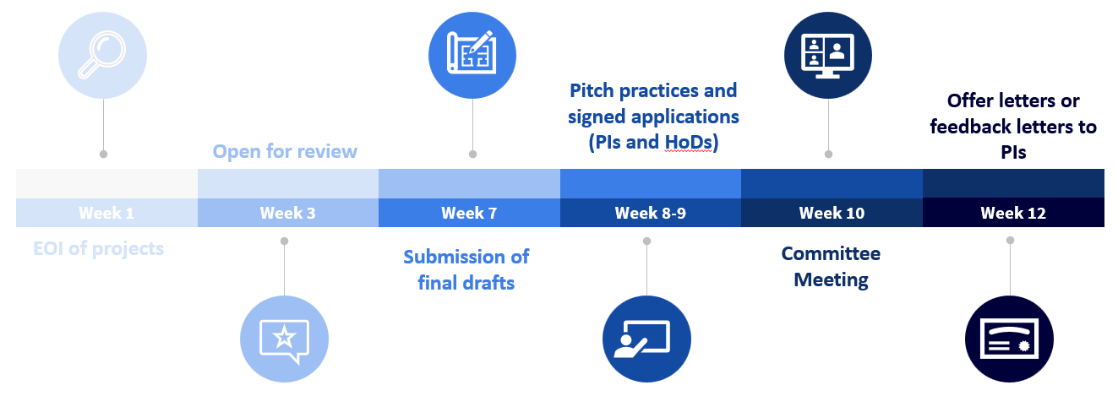
The application is a twelve-week process. A first draft application must be received by Week 5 for review by the Head of INV. The UCSF committee meeting is held in Week 10. Below is an outline of the application timetable:

HoD- Head of Department

Confirmation of Projects
UCSF awards must offer the prospect of a financial return. Each award is made under the terms set out in the pro forma Award Letter (See Appendix B). The normal Decrees and Statutes will apply when dealing with the exploitation of Intellectual Property and equity sharing in a spinout.
Awards may only be made in projects arising from research carried out in the University of Oxford. Researchers wishing to apply to UCSF for funding must contact a Licensing & Ventures Manager (“LVM”) at OUI. The project will be reviewed by the LVM, who will discuss the project with the Head of INV following a request for projects. If the Head of INV believes that the application meets the UCSF criteria, the application will be placed on a list of Principal Investigators (PIs) who have expressed an interest. All PIs who have submitted an expression of interest will be invited to apply to the next UCSF committee available.
Up to four applications can be presented during a UCSF committee. The Head of INV will determine how many applications the UCSF committee can review in any meeting. A PI will only be guaranteed their position at the next UCSF committee when a final application form completed to the satisfaction of the Head of INV has been received. The Head of INV has the right to withdraw submissions that do not meet the minimum threshold criteria. Applications will be received on a first come, first served basis. If there are no more available slots for the UCSF meeting, then the application can be allocated to a future UCSF meeting date. Where there is exceptional demand from applicants for a particular committee meeting, additional committee meetings can be arranged.

Completing Applications
All applicants are expected to complete an application form. An application form template can be obtained on OUI’s website, or by contacting a member of OUI’s INV team or individual LVMs. See Appendix A for application template example.
Applications should be completed by the PI and not the LVM. The LVM can be used to give advice to the researcher on the criteria of the UCSF. A GPT has been created on Oxford University’s Chat GPT system to give applicants feedback on the UCSF application. Teams are encouraged to use it for initial feedback. The INV team will provide feedback to applicants but will not draft applications.
Applications must be approved by the applicant’s Head of Department. This is evidenced through a signature on the completed application form. An application will not be presented to the UCSF committee if it has not been signed by the Head of Department.

Key Tips for a Strong Application

To ensure your proposal is competitive and aligned with the aims of this translational fund, please keep the following guidance in mind when preparing your application:

Use clear, plain English.
Applications should be accessible to reviewers from a range of backgrounds. Write for an educated layman—avoid unnecessary jargon and explain all technical terms and acronyms clearly. Ensure the language is concise and professional, and pay close attention to grammar, punctuation, and spelling throughout.

Answer every question fully.
Incomplete responses make it difficult for us to understand the project’s scope, value, and feasibility. Take time to address each question directly and thoroughly.

Articulate the problem you are solving.
Explain the unmet need or global challenge your project addresses. Why does this matter? Who benefits? What changes if your solution succeeds?

Focus on translation, not fundamental research.
Avoid copying content from fundamental research proposals—these differ significantly in aims, language, and expected outcomes. UCSF is a translational fund, so we are looking for the commercial potential and real-world application of your project. Clearly articulate how the work moves the technology closer to market, demonstrating impact, scalability, and a pathway to adoption.

Demonstrate commercial awareness.
Outline any commercial engagement that has shaped or informed your project. This may include engagement with major industry players, discussions around pilot programs, feedback from end users, evidence of market validation, or expressions of interest from potential partners and collaborators.

Check your financials carefully.
Ensure your budget is accurate, justified, and internally consistent. Confirm VAT is included where appropriate and that all costed items are supported by detailed quotes.

Avoid last-minute surprises.
Common pitfalls include using language that is too technical for an educated layman, not demonstrating a clear understanding of the market and the route to market, and not presenting a well-thought-out plan for next steps after UCSF funding. Long, complex sentences that could be simplified also weaken proposals. Taking the time to review your application thoroughly before submission will greatly improve its strength.

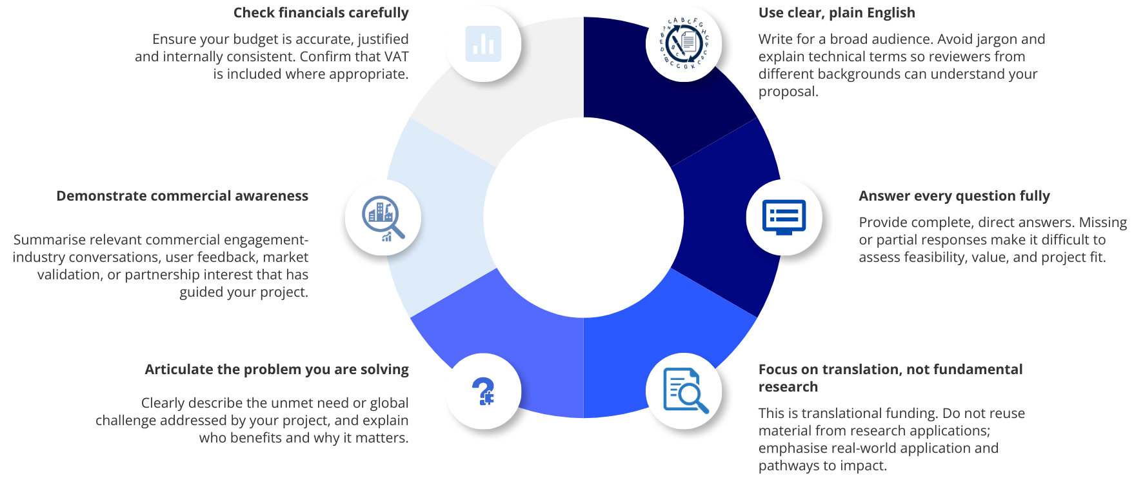

Pitch Presentation

Pitch Presentation
Once the application has been approved by the Head of Investments, applicants will be required to prepare a 10-minute presentation for the UCSF committee, which will be followed by a 20-minute Q&A session. Applicants are encouraged to practise their presentation with the INV team prior to the UCSF committee meeting. A time slot for practice will be arranged by a member of the Investments and New Ventures team at OUI. The presentation should cover the following:
- project background,
- market opportunity,
- the invention,
- IP position,
- team overview,
- commercial engagement,
- project timeline and
- why UCSF funding is being sought.

UCSF Committee meeting
The UCSF committee is a subset of the full OUI board. Currently, the following members are:
Nicola Blackwood Chairperson
Mairi Gibbs CEO of OUI
Jaci Barnett COO of OUI
Adam Workman Head of Investments of OUI
Jack Edmonson Chief Investment Officer at OSE
Matthew Wood Professor of Neuroscience
Len Seymour Professor of Gene Therapies
Simon Davis Professor of Molecular Immunology
Prior to the UCSF committee, the INV team will confirm the agenda timings with applicants and the LVM. Applicants are expected to be available between 9am and 12pm on the day of the UCSF committee meeting. Committee meetings are now all held online and will be recorded for minutes purposes.
During the committee meeting, the applicant will deliver a 10-minute presentation, followed by a 20-minute Q&A session with the committee. After the Q&A, the applicant will leave the Teams meeting to allow the committee to deliberate.

UCSF Offer Letter and Feedback Letter
After each committee meeting, all applicants will either receive an award letter or a feedback letter detailing the reasons why funding has not been offered. The decision of the UCSF committee is final. There is no right of appeal. An example of an offer letter can be found in Appendix B.
If the requested funds are not awarded, applicants may be invited to resubmit their application to a future UCSF committee, however, we cannot guarantee that an unsuccessful applicant will be able to resubmit at the next committee meeting. The reapplication date will be dependent on a slot being available.
Once an award letter is received, the PI and the Departmental Finance Office will need to sign the letter and return it to OUI. The Department to which funds will be paid will also need to raise a cost centre for the project. The award letter and application will then be sent for approval for payment to the University Finance Office.
The signed documents will then be handed over to the OUI Finance Department for payment.

Funds Awarded
Funds can be awarded either to the Department (1) or to a Company (2):
- If the funds are awarded to the Department, any intellectual property generated as a result of work financed by the grant will remain the property of the University.
  - If a licence results from work financed by the grant, the net revenue will be distributed as per the table below, where the portion allocated to the General Revenue Account will be transferred back to the Fund once the University has discharged its obligation to pay the employer’s National Insurance Contribution.
  - If new company results from work financed by the grant, the grant will be treated as an equity investment, and the Fund will be allotted shares in the company on the same terms as the investors in the first equity round. The University and OSE will be allotted shares in the company per their funding contribution. In addition, at the formation of the company, the University and OSE each have the right to subscribe for further shares at the same price as, and on a basis no less favourable than, the first-round investors up to an aggregate limit of £250,000 per company.
- If the funds are awarded to a Company, a separate agreement between the University and the Company will be required to document the award and its future conversion into equity. The grant will be treated as an equity investment as detailed in (1b).

Total net revenue | Researcher(s) | General Revenue Account | Department(s)
Up to £50K | 85.7% | 14.3% | 0%
Band from £50K and  up to £500K | 45% | 30% | 25%
Over £500K | 22.5% | 40% | 37.5%

Audit Process
Once the project has concluded, the audit process will commence. We will provide you with two forms: an Academic Close Out Report and a Finance Close Out Form. The Academic Report must be completed by the project team and should detail the work undertaken during the project period, highlight any significant outcomes achieved, and indicate whether all work packages have been completed. In addition, it should outline the next steps following the conclusion of the UCSF project and note any emerging commercial interest or opportunities for further development. The Finance report should be submitted to your departmental finance team and must outline all expenditures, ensuring they align with the approved budget in the original application. Any unspent funds will be returned to the University in accordance with the award letter.

Programme Management
The Translational Research Office in the Medical Science Division provides a range of videos including tips on translational application writing. News, Training & Events — University of Oxford, Medical Sciences Division
Notes on costing:
- Full VAT must be included in project costing
- Full-time University staff cannot be paid
- Incoming employees to be hired using the UCSF award will not cover any full economic costs (FECs). Please refer to the link for University FEC Overview Costing | Research Support (ox.ac.uk).
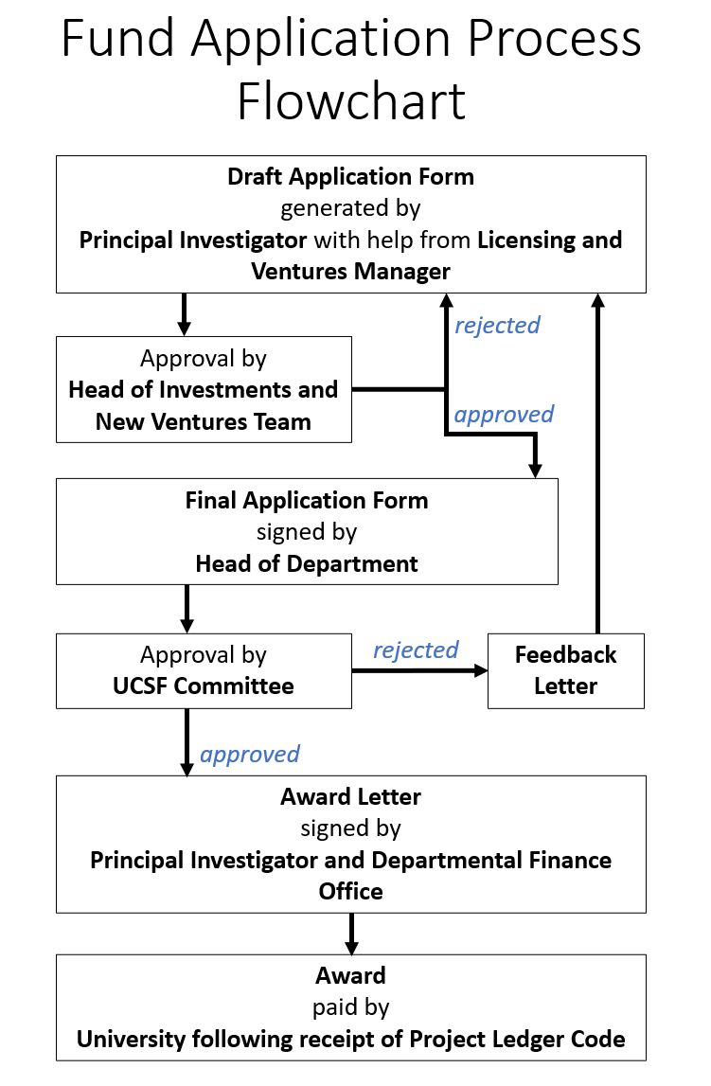

Appendix A – UCSF application form

Project Title: |  |  |  |  |  |  |  |  | OUI Project No:
OUI Licensing and Ventures Manager: |  |  |  |  |  |  |  |  | UCSF No:
Researcher name (s):
Department (s):
Correspondence Address:
Email address:
Funding sources |  |  | Total value of project: |  |  |  |  |  | £
 |  |  | Value requested from UCSF |  |  |  |  |  | £
Project Dates: |  |  | [Start date] Make sure this is a realistic time frame |  |  |  |  |  | [End date] (Max 18 months)
Project Stage: (delete as appropriate) |  |  | Initial proof of concept |  | Pre-patent research |  | Reduction to practice |  |  |  | Commercial demonstration
Vision Statement (max 100 words)
Explain how your innovation could transform the industry or healthcare, in language a non-expert can understand. Who benefits, and why this represents a meaningful improvement.
Brief description of technology/invention (100 words)
Describe the technology in practical terms. What problem does it solve, how does it work, and what makes it different from existing solutions?
List major milestones the team has achieved in the development and de-risking of the technology. What is your current stage of development?

Project Summary (100 words)
A short, non-confidential summary of the project, written for a non-expert audience.
This may be used to showcase previously funded projects and should not include proprietary or confidential information
This section should be distinct from the technology description above, as it outlines the specific project work and activities to be undertaken with the UCSF award, rather than the technology itself.

Critical Project Deliverables (UCSF Award Period) (250 words)
Single critical proof point
• What is the single critical experiment or proof point required during this project to enable a spinout or licence? (e.g. In vivo efficacy in a disease model, prototype achieving required performance threshold)
• How will the UCSF-funded project deliver this proof point?

Critical validation data
• What additional technical, performance, or economic data do potential customers, partners, or investors want to see?
• Where possible, reference market feedback (e.g., “Company X indicated they would need to see Y”).
• Clearly describe how the UCSF project will generate this validation data.

Market opportunity and industrial engagement (350 words) (include information relating to gaps in market, market size, customer interaction, possible route to market (e.g. license))
We are looking for
Market opportunity
• An understanding of the overall market opportunity, including total market size and the realistic share you aim to capture
• A clearly defined beachhead market, including its size and characteristics
• Identification of your early adopters within this market
Route to market
• A clear and credible route to market, preferably leveraging UCSF support where appropriate
Competitive landscape
• What is the current best available solution (physical sciences) or standard of care (life sciences)?
• How does your approach build on and improve upon existing solutions?
Market validation and engagement
• Who have you engaged with (e.g. companies, clinicians, end users, partners)?
• What specific feedback did you receive?
• How has this feedback informed and shaped the proposed project?
Innovation of the science (200 words) (What is it, how does it work, why is it novel?)
Please use terms suitable for an educated layman
Explain how your technology differentiates itself focusing on the commercial potential of the science
IP position (150 words) (include views of patent agents and/or OUI regarding prior art searches, patent/ competition landscape, patentability)
Please give clear details of all intellectual property including copyright, trademark, trade secret or potential thereof
Project plan (300 words total) (please add additional rows where necessary)
Task breakdown | Description |  |  |  |  |  |  | Start date |  | End date |  |  | Cost
Work Package 1 | Make sure Work Packages enable a clear progression from one Project Stage to the next |  |  |  |  |  |  |  |  |  |  |  | £
Sub-task 1a | Work Packages should show realistic timescales and budget |  |  |  |  |  |  |  |  |  |  |  | £
Sub-task 1b | Make sure the Cost tallies with the value of the project! |  |  |  |  |  |  |  |  |  |  |  | £
Work Package 2 |  |  |  |  |  |  |  |  |  |  |  |  | £
Sub-task 2a |  |  |  |  |  |  |  |  |  |  |  |  | £
Sub-task 2b |  |  |  |  |  |  |  |  |  |  |  |  | £
Work Package 3 |  |  |  |  |  |  |  |  |  |  |  |  | £
Sub-task 3a |  |  |  |  |  |  |  |  |  |  |  |  | £
Sub-task 3b |  |  |  |  |  |  |  |  |  |  |  |  | £
Project deliverables: (what you hope to achieve) (100 words)
Brief description of deliverable
Work Package 1
Work Package 2
Work Package 3
Background to research group/ management team (200 words)
Only include people that are necessary to the project. Highlight anyone whose salary will need to be paid from the fund. Include details on length of contract and ability to spend time working on the project
N.B. UCSF / OIF projects within the University are relatively short term and small scale and are treated as incremental activity for Departments. They must be costed on a marginal basis and only additional costs to the University will be granted by the funds. Thus there are no indirect costs to be added to the direct costs you identify below.
Item |  | Amount (£) |  |  |  | * Please provide details. NB include VAT for any external purchases or bought-in services.
 |  | UCSF |  | Match
Salaries (incl employer’s costs) |  |  |  |  |  | Include name of person whose salary will be paid
Consumables*
Equipment*
Computer Hardware*
Computer Software*
Bought-in services* |  |  |  |  |  | These should not be the sole purpose of the fund
Other*
Sub-total
TOTAL (UCSF + Other sources) |  | £ Make sure the Cost aligns with the value of the project!
CONTRIBUTIONS FROM MATCH SOURCES (Detail source of contributions and their value as appropriate)
SOURCE |  | TYPE  Grant/ in kind? |  |  |  | AMOUNT
Please explain why the UCSF is the most appropriate funding source for this project. (100 words) Please indicate why other sources of funding cannot be used e.g. IAA, MRC CiC, OxSciences.
Please include any other funding sources you have applied to, whether you were successful, and any feedback received. If unsuccessful, explain how you have addressed the feedback or why this feedback makes UCSF the most appropriate funding source now.
Next steps after UCSF funding: (100 words) (e.g. license technology, further research, form company)
We want to see that UCSF is helping get the project from one stage to the next. Preferably, from a position where it is only eligible for this sort of funding to where it will be attractive for other sources of investment.

Appendix B – UCSF Award letter

Professor XXX  Oxford OX | XX January 2026

Dear Prof. XXX

University Challenge Seed Fund (the ‘Fund’)
ref: Award UCSF XXX

I am pleased to confirm that, in response to your application, the Investment Advisory Committee of the Fund is prepared to recommend an award of up to £XXXX under the following conditions.

- Of the award, the University of Oxford (“the University”) will contribute £XXXX and Oxford Science Enterprises Plc (“OSE”) will contribute £XXXX.
- The money will be used exclusively for the work described in your application (as appended in Appendix 1). Prior to the transfer of the award to the Department a project code will be created on the Department’s finance systems. This is required to ensure transparency of expenditure on the project. The code will have to be given to Oxford University Innovation in order to transfer the award to the Department.
- The project will start on XX/XX/2025 and finish on XX/XX/2025. There will be no cost extensions allowed in the project. Any time extensions must be submitted in writing to Adam Workman, Head of New Ventures at Oxford University Innovation.
- Any intellectual property generated as a result of work financed by the grant will remain the property of the University.
- If a new company results from work financed by the grant, the grant will be treated as an equity investment in that company. The University and OSE will be allotted shares in the company in accordance with their funding contribution detailed in condition 1 above. These shares will be subscribed for by the University and by OSE, in such number as is equivalent to the value of the contribution of each party, at the price paid by the first-round investors. In addition, at formation of the company, the University and OSE each has the right to subscribe for further shares at the same price as, and on a basis no less favourable than, the first-round investors up to an aggregate limit of £250,000 per company.
- If the company is spun out without first round investors, the company will agree a side letter with the University and OSE at the time of spinning out which sets out a mechanism under which shares will be issued to the University and OSE under the terms in above in condition 5.
- If, rather than a new company, results from work financed by the grant generate licensing income, a portion of the net revenue will be allocated to the University and OSE in accordance with the University’s Regulations. The revenue will be allocated to the University and OSE in proportion with their initial contribution to the award. The researcher(s) share will not be affected.
- In order to help monitor the success of the project, Oxford University Innovation will expect project close out reports to be completed by the Principal Investigator and Finance Department at the end of the project. If the reports are not returned the Principal Investigator will be unable to apply for future funding until the project close out reports are returned.
- If a project has not commenced within six months of the award date Oxford University Innovation reserves the right to terminate the project and request the return of the funds.
- At the end of the project any residual funds should be transferred back to the Fund if a new company has not been created. If a new company has been created any residual funds should be transferred to the new company following the allocation of shares. Any assets purchased by the award should be transferred to the new company following the allocation of shares.
- This offer will remain open for four weeks from the above date.

Yours sincerely

Adam Workman Jim Wilkinson

Oxford University Innovation Oxford Science Enterprises

Please DocuSign to indicate your acceptance of these conditions.

Accepted: Accepted:

___________________ _______________________
Principal Investigator(s) Departmental Finance Office
Date: Date:

UNIVERSITY CHALLENGE SEED FUND / OXFORD INNOVATION FUND PROJECT CLOSE OUT REPORT

Project Title |  | UCSF / OIF ref
Principal Researchers |  | OUI Project ref
Department |  | OUI Technology Transfer Manager
Lead Researcher
Contact address
Contact email
Please detail the key activities undertaken during the project
What outputs/outcomes have stemmed from your completed project? Did you achieve what you set-out to do as detailed in your application?
What are your plans for taking the project forward and how is that to be funded?
Has there been any interest expressed to take the project forward by commercial partners or financial investors?

UNIVERSITY CHALLENGE SEED FUND / OXFORD INNOVATION FUND PROJECT CLOSE OUT REPORT

Project Title |  |  | UCSF / OIF ref
Principal Researchers |  |  | OUI Project ref
Department |  |  | OUI Technology Transfer Manager
Finance Dept Contact
Contact address
Contact email
Project code, A/C no, cost centre
Budget and contributions – Please detail the actual expenditure on your project against the budget requested
Expenditure type | Description | Budget awarded (£) |  | Actual Expenditure (£)
Salaries (inc. employer’s costs)
Consumables*
Equipment*
Computer Hardware*
Computer Software*
Bought-in services*
Other*
 | TOTAL

* Please include VAT for any external purchases or bought-in services

