e-Health Impact Questionnaire
User guide Version 1.3
Laura Kelly, Crispin Jenkinson, Sue Ziebland
09.11.2015

© 2013, Health Services Research Unit, University of Oxford For further information and use of final version of this questionnaire, please contact Laura Kelly (laura.kelly@dph.ox.ac.uk) or Professor Crispin Jenkinson (crispin.jenkinson@dph.ox.ac.uk)

Contents
Overview 3
Development of the eHIQ 4
eHIQ-Part 1 6
eHIQ-Part 2 7
Scoring of the eHIQ 9
Administration of the eHIQ 12
Appendix 1 14
Appendix 2 21
References 29

Overview

This guide has been developed in order to give users basic information on how to use the eHealth Impact Questionnaire (the eHIQ). An overview is given of the eHIQ development, followed by a description of the eHIQ domains and item content. Guidelines relating to the scoring and administration of the instrument are also provided. All questionnaire items and recommended layout are included in the appendix.
The eHIQ assesses the impact of using health-related websites. The questionnaire consists of two independently administered and scored parts (eHIQ-Part 1 and eHIQ-Part 2). The eHIQ-Part 1 consists of 11 items asking about a person’s general attitudes towards health-related websites. The eHIQ-Part 2 consists of 26 items asking about a person’s views regarding a specific health-related website. Both parts of the questionnaire have a five point response category for all items ranging from ‘Strongly disagree to Strongly agree’.
Raw scores can be calculated using a simple scoring algorithm for all subscales. Raw scores are transformed to a 0-100 metric, where 0=lowest possible negative value and 100=highest possible positive value for each respective subscale. The eHIQ is a self-complete questionnaire which is designed to be administered electronically.

Development of the eHIQ

The eHIQ was developed using a five stage process as outlined below.
Stage 1- Item generation
Items were informed through a review of relevant literature [1] and secondary qualitative analysis of 99 narrative interviews from the Oxford Health Experiences Research Group archive. Interviews related to patient and carer experiences of health and represented a range of health conditions. Five themes were found to be applicable to the impact of using health-related websites: 1) Information, 2) Feeling supported, 3) Relationships with others, 4) Experiencing health services and; 5) Affecting behaviours. Statements, in the form of verbatim quotes, representing identified themes were re-cast as questionnaire items and shown for review to an expert panel consisting of six clinicians and academics with interests in the field of e-health.
Stage 2- Cognitive de-brief interviews
Cognitive debrief interviews (n=21) were used to assess items for face and content validity. Cognitive interviewing is a qualitative method used find to out how respondents understand and answer structured questions in order to improve the validity and acceptability of items [2, 3]. Cognitive interviewing confirmed: 1) the instructions were easy to understand and the rubric clearly indicated how participants were supposed to answer items, 2) participants found all items retained relevant to the topic and acceptable to answer, 3) the response options were appropriate to the item stem and the response options adequately covered the potential range of agreement, and 4) the electronic format was appropriate for use among a range of participants with varying levels of computer proficiency. Twenty-nine items were deleted and nine items were added in total, leaving 62 items to enter psychometric testing. (see [4]for further detail for Stages 1 and 2)
Stage 3- Item reduction and scale generation
Following expert and patient refinement, two independent item pools were confirmed as suitable to enter psychometric testing. The first item pool contained 23 items asking respondents about their general attitudes towards health related websites whilst the second item pool contained 39 items asking the respondent about their attitudes towards a specific health related website. All items had a five point Likert response scale (Strongly disagree- Strongly agree).
The two part questionnaire was administered online to obtain a dataset with which to perform appropriate statistical and psychometric analysis. Open recruitment took place through advertised research invites on health related websites (for example, health blogs, online discussion forums, social networking sites (Facebook and Twitter), health websites news pages, health websites research volunteer pages, local news online advertisements, research and policy volunteer email list).
Items were subjected to preliminary data checks to ensure their suitability to proceed in the analysis. Items were checked for floor and ceiling effects (to identify items with >40% of respondents selecting one of the extreme response options) and for items which had large amounts of missing data (> 10% non-response). No items were removed due to floor or ceiling effects or missing responses.
Items which had poor correlations (<0.2) with a large number of items, low item total correlations (<0.3) and items which reduced the Cronbach’s alpha value were identified [5]. Items displaying a high number of poor correlations with other items or items with poor Cronbach’s alpha statistics were iteratively removed. The eHIQ-Part 1 was reduced to 14 items and the eHIQ-Part 2 was reduced to 34 items.
Stage 4- Validity and reliability of questionnaire
The reduced eHIQ and appropriate reference measures were administered online to confirm domains present using exploratory factor analysis, to examine convergent validity and to test reliability. Items were subjected to Principle Components Analysis (PCA) using SPSS. An oblique factor solution was sought using Direct Oblimin rotation [6].
Analyses resulted in the removal of three items from the eHIQ-Part 1 and confirmed the presence of two domains: 1) Attitudes towards online health information and 2) Attitudes towards sharing health experiences online. Eight items were removed from the eHIQ-Part 2 and three domains were retained: 1) Confidence and identification, 2) Information and presentation and 3) Understanding and motivation. The two domains in eHIQ-Part 1 explained 56.6% of the variance while the three domains in eHIQ-Part 2 explained 61.9% of the variance.
Results confirmed expectations that the eHIQ domains were moderately related to reference measures of similar constructs. All domains showed good internal consistency achieving a Cronbrach’s alpha of ≥ 0.77. Good test-retest reliability was found among those who completed the eHIQ again after a two week interval (n=83). Intra-class correlation coefficients ranged from 0.76 to 0.91 for all domains. See [7] for Stages 3 and 4.
Stage 5- Summary Index Scores
Factor analysis aims to explain the maximum amount of variance within a set of items using the smallest number of latent factors. Implicit in all oblique factor rotations are higher-order factors [8]. A higher order factor analysis was therefore carried out for the eHIQ-Part 1 and the eHIQ-Part 2 to see if the sub-scales in each part of the questionnaire could be aggregated to create two respective summary index scores.
Data from the first order factor analyses carried out in Stage 4 provided input for each higher order factor analysis. For eHIQ-Part 1 items, one factor with an eigenvalue of value greater than one was extracted, explaining 76.2% of the variance. The higher order factor, referred to as Attitudes towards the use of the internet in relation to health, was assessed for internal consistency achieving a Cronbach’s alpha of 0.78 (n=169). For eHIQ-Part 2, one factor with an eigenvalue of value greater than one was extracted, explaining 63.1% of the variance. The higher order factor, referred to as Overall impact of using a specific health-related website, was assessed for internal consistency achieving a Cronbach’s alpha of 0.87 (n=163). These results supported summing items in each questionnaire part to create a total index scores.

eHIQ-Part 1

The eHIQ-Part 1 contains 11 items asking about participants general attitudes towards health related websites. The two scales relate to:
- Attitudes towards online health information- Items represent general attitudes towards using the internet to access health information.
- Attitudes towards sharing health experiences online- Items measure a person’s ease with using online information, particularly emphasising a person’s openness to learning and gaining support from other peoples experiences.

Table 1: eHIQ-Part 1 items per subscale
Scale | Items
Attitudes towards online health information  (5 items) | 1. The internet is a reliable resource to help me understand what a doctor tells me.
 | 2. The internet can help the public to know what it is like to live with a health problem.
 | 3. The internet can be useful to help people decide if their symptoms are important enough to go to see a doctor.
 | 4. I would use the internet if I needed help to make a decision about my health (for example, whether I should see a doctor, take medication or seek other types of treatment).
 | 5. I would use the internet to check that the doctor is giving me appropriate advice.
Attitudes towards sharing health experiences online  (6 items) | 6. The internet is a good way of finding other people who are experiencing similar health problems.
 | 7. It can be helpful to see other people’s health-related experiences on the internet.
 | 8. The internet is useful if you don’t want to tell people around you (for example, your family or people at work) how you feel.
 | 9. It can be reassuring to know that I can access health-related websites at any time of the day or night.
 | 10. The internet is a good way of finding other people who are facing health-related decisions I may also face.
 | 11. Looking at health-related websites reassures me that I am not alone with my health concerns.

eHIQ-Part 2

The eHIQ-Part 2 contains 26 items asking about views on the health related website under examination. The three scales relate to:
- Confidence and identification–Items reflect confidence to discuss health with others and a person’s ability to identify with the website.
- Information and presentation - Items reflect trust and suitability of website content.
- Understanding and motivation –Items reflect understanding and learning about relevant information and motivation to take action.
Table 2: eHIQ-Part 2 items per subscale
Scale | Items
Confidence and identification  (9 items) | 10. The website prepares me for what might happen to my health.
 | 11. The people who have contributed to the website understand what is important to me.
 | 14. I feel I have a sense of solidarity with other people using the website.
 | 15. I can identify with other people using the website.
 | 17. I value the advice given on the website.
 | 18. The website gives me confidence that I am able to manage my health.
 | 19. I feel I have a lot in common with other people using the website.
 | 20. The website gives me the confidence to explain my health concerns to others.
 | 23. The website makes me more confident to discuss my health with the people around me (for example, my family or people at work).
Information and presentation  (8 items) | 3. The information on the website left me feeling confused.
 | 5. The website provides a wide range of information.
 | 6. The language on the website made it easy to understand.
 | 9. I can easily understand the information on the website.
 | 12. I trust the information on the website.
 | 24. Photographs and other images were used appropriately on the website.
 | 25. I found the images on the website distressing.
 | 26. The website is easy to use.
Understanding and motivation  (9 items) | 1. The website encourages me to take actions that could be beneficial to my health.
 | 2. The website has a positive outlook.
 | 4. The website includes useful tips on how to make life better.
 | 7. I feel more inclined to look after myself after visiting the website.
 | 8. I have learnt something new from the website.
 | 13. I would consult the website if I had to make a decision about my health.
 | 16. On the whole, I find the website reassuring.
 | 21. The website helps me to have a better understanding of my personal health.
 | 22. The website encourages me to play a more active role in my healthcare.

Scoring of the eHIQ

This section provides instructions for calculating domain scores for the eHIQ-Part 1 and the eHIQ-Part 2. Each domain is transformed to a 0-100 metric, where 0=lowest possible negative value and 100= highest possible positive value for each respective subscale.
Each scale is calculated as follows: domain score = the sum of the final values for all the items in a given domain minus the minimum raw score, divided by the range between the maximum and minimum raw score for the given domain multiplied by 100. Scores can be calculated using a three step process.
Step 1: Record or enter item response
Responses for all items are exported from the data collection platform used. All items are coded the same way. It is recommended that data is recorded using the following codes:
- 1= Strongly disagree
- 2= Disagree
- 3= Neither agree nor disagree
- 4= Agree
- 5= Strongly agree
Step 2: Recode item values
Two items in eHIQ-Part 2 should be recoded to obtain their final item value as outlined in Table 3.
Table 3: Calculating final item values
Questionnaire | Item number | Original value | Final value
eHIQ-Part 2 | 3,25 | 1 | 5
 |  | 2 | 4
 |  | 3 | 3
 |  | 4 | 2
 |  | 5 | 1

Step 3: Determining scale scores
After item recoding, a total score for each scale can be calculated. Tables 4 and 5 provide the item numbers which belong to each scale and the minimum and maximum raw scale scores. These values should be entered into the formula below.
Table 4: eHIQ-Part 1 items per subscale and maximum scores
Subscale | Sum of final raw values for item numbers | Minimum raw score | Maximum raw score
Attitudes towards online health information | 1+2+3+4+5 | 5 | 25
Attitudes towards sharing health experiences online | 6+7+8+9+10+11 | 6 | 30

Table 5: eHIQ-Part 2 items per subscale and maximum scores
Subscale | Sum of final raw values for item numbers | Minimum raw score | Maximum raw score
Confidence and identification | 10+11+14+15+17+18+19+20+23 | 9 | 45
Information and presentation | 3+5+6+9+12+24+25+26 | 8 | 40
Understanding and motivation | 1+2+4+7+8+13+16+21+22 | 9 | 45

Raw scale scores can be calculated though summing the final response values for all the items in a given scale minus the minimum raw score and dividing the value by the range between the maximum and minimum raw score. The raw scale score can then be used to transform the score to a 0-100 metric by multiplying the raw domain score by 100 (See formula below).

Formula for scoring each subscale=
$\frac{Sum of scores of each item in scale-minimum raw score}{Maximum raw score-minimum raw score} ×100$

Worked example:
A person responds in the following manner for ‘Information and presentation’ in eHIQ-Part 2 (Items included in scale: 3+5+6+9+12+24+25+26).
Table 6: Scale calculation for Scale Information and presentation
Items included | Step 1 | Step 2 |  | Step 3
 | Exported coded response value | Original response value | Final response value | $$\frac{Sum of scores of each item in scale-minimum raw score}{Maximum raw score-minimum raw score} ×100$$
Item 3 | 4 | 4 | 4 | Scale score = $\frac{(4+4+5+3+3+2+5+1)-8}{\begin{aligned}40-8 \\ \end{aligned}}×100$  =$\frac{19}{32 }×100$  =0.59 x 100  =59.4
Item 5 | 2 | 2 | 4
Item 6 | 5 | 5 | 5
Item 9 | 3 | 3 | 3
Item 12 | 3 | 3 | 3
Item 24 | 2 | 2 | 2
Item 25 | 1 | 1 | 5
Item 26 | 1 | 1 | 1
Recode items 3 and 25 (See Table 3)

Calculation of Summary Index Scores
Summary index scores can be calculated by finding the mean subscale score for each questionnaire part. The formula is outlined below.
Formula for summary index score=
$\frac{Sum of subscale scores}{Number of subscales}$

Administration of the eHIQ

The eHIQ contains two independent parts (the eHIQ-Part 1 and the eHIQ-Part 2). One part can be used without administering the other part if that is appropriate to the study design. For use in a trial of a health website as an intervention, it is recommended that the eHIQ-Part 1 (general attitudes towards health-related websites) is administered at base line (Time 1). It may be administered again at follow up, however it should be noted that scores are unlikely to change during a short intervention period. The eHIQ-Part 2 asks about a person’s views on a specific health-related website (i.e. the intervention or control website). The eHIQ-Part 2 should always be asked post intervention (Time 2). Both questionnaire parts have a five point response scale (Strongly disagree – Strongly agree).
The eHIQ is suitable for electronic self-administration and has been found to be suitable for use among people with long term conditions, people considering a health behaviour change and carers of people with long term conditions.
The approximate time to complete the eHIQ-Part 1 and the eHIQ-Part 2 is 10-15 minutes (excluding the time taken to browse an intervention website).

Recommended format
To reduce measurement error caused by response bias or overlooked items it is recommended that the questionnaire items are presented in a simple grid format with a fixed width survey template (See Figure 1). Where possible, the number of items appearing on one webpage should be limited so that the respondent is not required to ‘scroll down’ in order to access the ‘continue’ button located at the bottom of the page. The use of a progress bar is also recommended (See Figure 2).
The use of colour should be restrained so that consistency and readability are maintained. Clear instructions on how to complete the questionnaire should be inserted before the participant commences the questionnaire. It is recommended that participants are not forced to respond to any given item, but that a prompt box may appear to remind the participant that they have not responded to a particular item before continuing to the next page.
Appendix 2 demonstrates the recommended electronic layout for the complete eHIQ questionnaire.

Figure 1: Grid formatted items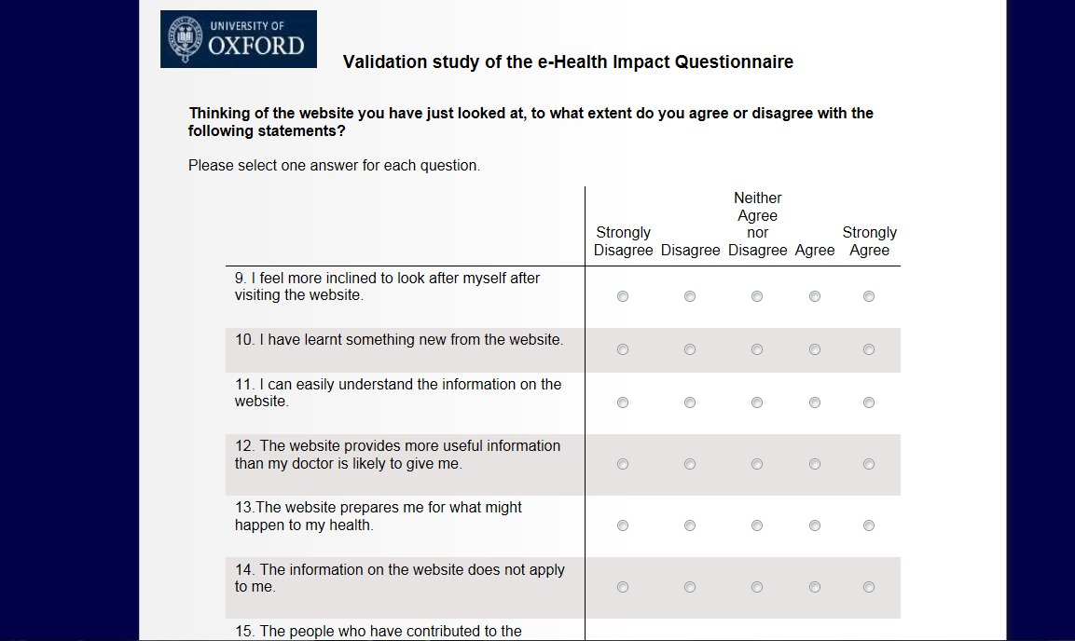
Insert logo where applicable
Title of study
Grid format
Fixed width template

Figure 2: Continue button and progress bar
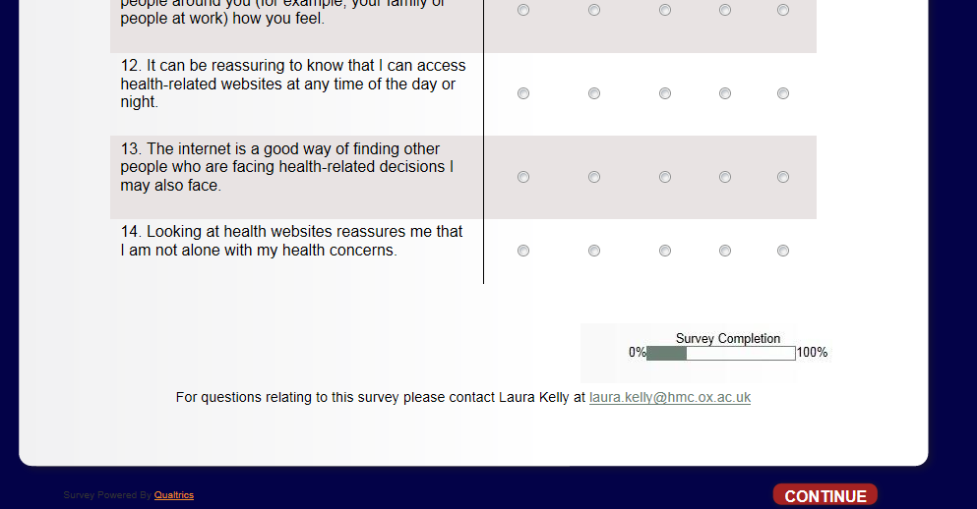
Progress bar
Insert contact details on each webpage
Include a continue button

Appendix 1
The e - Health Impact Questionnaire
[Enter participant information regarding study and relevant instructions depending on software, for example: ‘Please note that if the survey is inactive for 30 minutes the system may time out and data will be lost.’]
Part 1
This section asks about your general attitudes towards health-related websites.
In this section 'health- related websites' can include websites that contain factual health information, stories of people’s experiences of health, blogs about health or health discussion forums.
Please begin by completing the questions below.
 | Select the box which applies to you.
To what extent do you agree or disagree with the following statements? | Strongly disagree | Disagree | Neither agree nor disagree | Agree | Strongly agree
1. The internet is a reliable resource to help me understand what a doctor tells me.
2. The internet can help the public to know what it is like to live with a health problem.
3. The internet can be useful to help people decide if their symptoms are important enough to go to see a doctor.
4. I would use the internet if I needed help to make a decision about my health (for example, whether I should see a doctor, take medication or seek other types of treatment).
5. I would use the internet to check that the doctor is giving me appropriate advice.
For questions relating to this survey please contact: XXXX
Continue to new page

 | Select the box which applies to you.
To what extent do you agree or disagree with the following statements? | Strongly disagree | Disagree | Neither agree nor disagree | Agree | Strongly agree
6. The internet is a good way of finding other people who are experiencing similar health problems.
7. It can be helpful to see other people’s health-related experiences on the internet.
8. The internet is useful if you don’t want to tell people around you (for example, your family or people at work) how you feel.
9. It can be reassuring to know that I can access health-related websites at any time of the day or night.
10. The internet is a good way of finding other people who are facing health-related decisions I may also face.
11. Looking at health websites reassures me that I am not alone with my health concerns.

For questions relating to this survey please contact: XXXX
Continue to new page

Insert ‘You have completed X of X sections in this questionnaire.’ Or insert progress bar
Instructions below will change according to intended use
Please follow the instructions below:
1. Click on the link to the health-related website below. This will open a new page in your browser.
2. Please take 10-15 minutes to browse the areas of this website which are of interest to you.
3. When you have finished browsing the website, return to this page and click 'continue' to complete the remaining questions.
Health- related website: [Insert website]
(Please note that if you do not return to this questionnaire within 30 minutes, this session will time out)

For questions relating to this survey please contact: XXXX
Continue to new page
Part 2
This section asks about your views on the health-related website you have just looked at.

 | Select the box which applies to you.
Thinking of the website you have just looked at, to what extent do you agree or disagree with the following statements? | Strongly disagree | Disagree | Neither agree nor disagree | Agree | Strongly agree
1. The website encourages me to take actions that could be beneficial to my health.
2. The website has a positive outlook.
3. The information on the website left me feeling confused.
4. The website includes useful tips on how to make life better.
5. The website provides a wide range of information.
6. The language on the website made it easy to understand.
7. I feel more inclined to look after myself after visiting the website.

For questions relating to this survey please contact: XXXX
Continue to new page

 | Select the box which applies to you.
Thinking of the website you have just looked at, to what extent do you agree or disagree with the following statements? | Strongly disagree | Disagree | Neither agree nor disagree | Agree | Strongly agree
8. I have learnt something new from the website.
9. I can easily understand the information on the website.
10. The website prepares me for what might happen to my health.
11. The people who have contributed to the website understand what is important to me.
12. I trust the information on the website.
13. I would consult the website if I had to make a decision about my health.
14. I feel I have a sense of solidarity with other people using the website.

For questions relating to this survey please contact: XXXX
Continue to new page

 | Select the box which applies to you.
Thinking of the website you have just looked at, to what extent do you agree or disagree with the following statements? | Strongly disagree | Disagree | Neither agree nor disagree | Agree | Strongly agree
15. I can identify with other people using the website.
16. On the whole, I find the website reassuring.
17. I value the advice given on the website.
18. The website gives me confidence that I am able to manage my health.
19. I feel I have a lot in common with other people using the website.
20. The website gives me the confidence to explain my health concerns to others.
21. The website helps me to have a better understanding of my personal health.

For questions relating to this survey please contact: XXXX
Continue to new page

 | Select the box which applies to you.
Thinking of the website you have just looked at, to what extent do you agree or disagree with the following statements? | Strongly disagree | Disagree | Neither agree nor disagree | Agree | Strongly agree
22. The website encourages me to play a more active role in my healthcare.
23. The website makes me more confident to discuss my health with the people around me (for example, my family or people at work).
24. Photographs and other images were used appropriately on the website.
25. I found the images on the website distressing.
26. The website is easy to use.

For questions relating to this survey please contact: XXXX
Continue to new page

Appendix 2
Recommended electronic layout for eHIQ items
[Introductory pages should provide participant with information regarding study and relevant instructions depending on software, for example: ‘Please note that if the survey is inactive for 30 minutes the system may time out and data will be lost.’ N.B the inclusion of a progress bar is also recommended]

Page 1
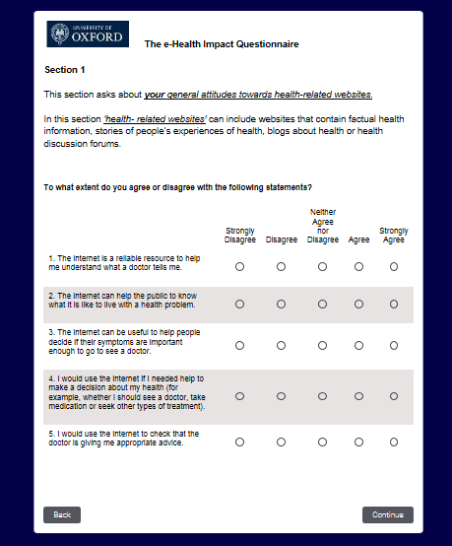
Insert own logo where applicable

Page 2
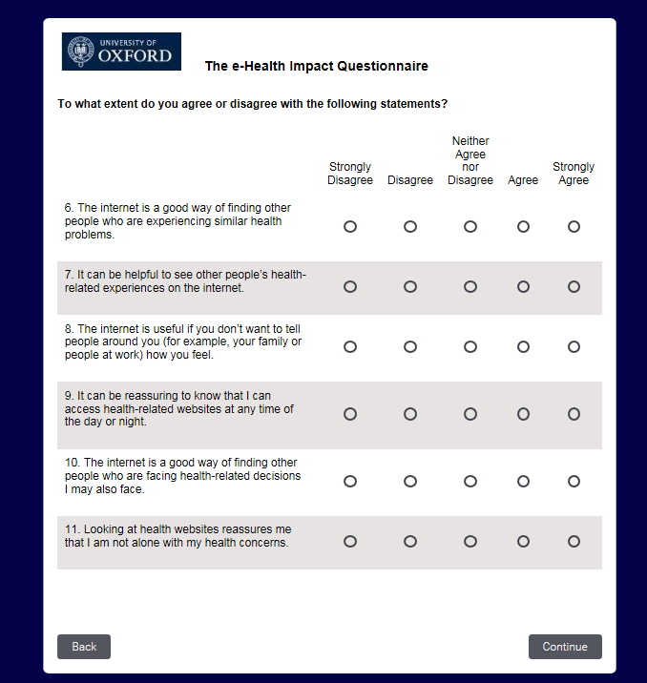

Page 3
[The information included in page 3 will depend on the website being assessed and study design.]
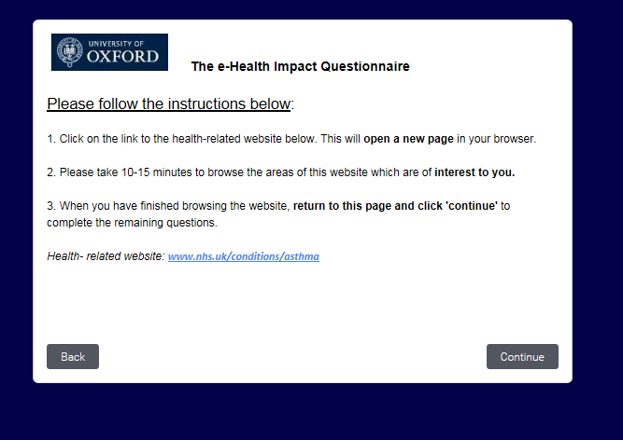

Page 4
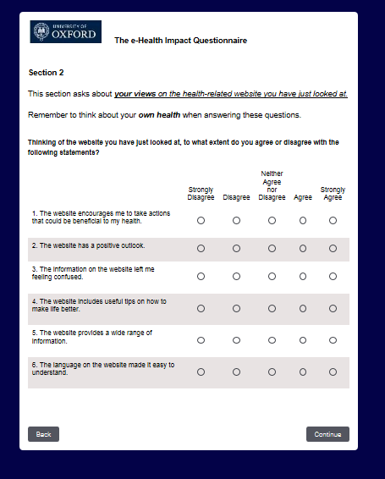

Page 5
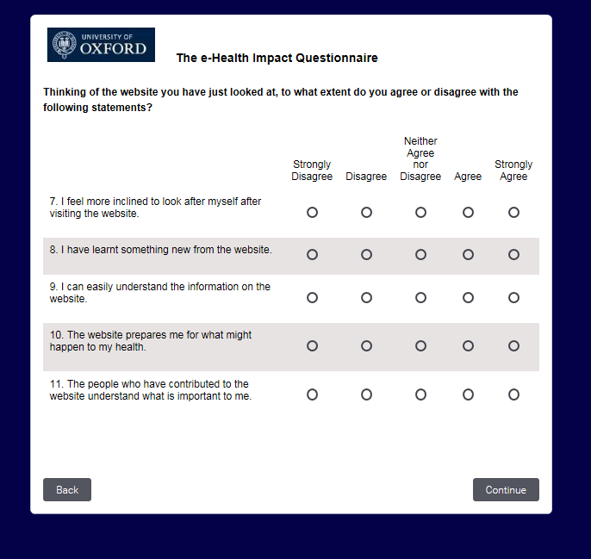

Page 6
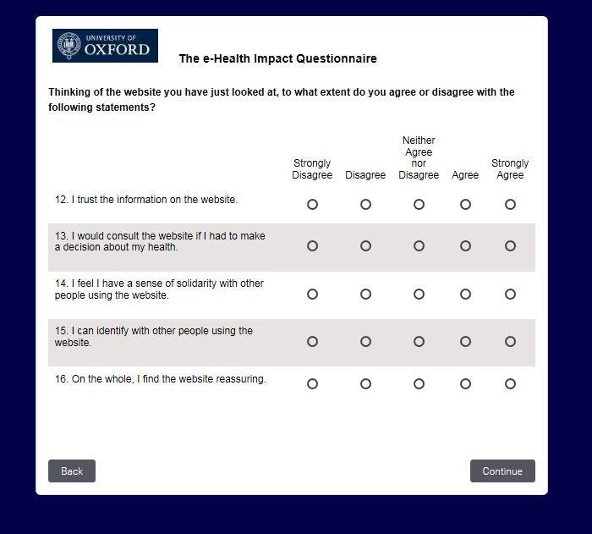

Page 7
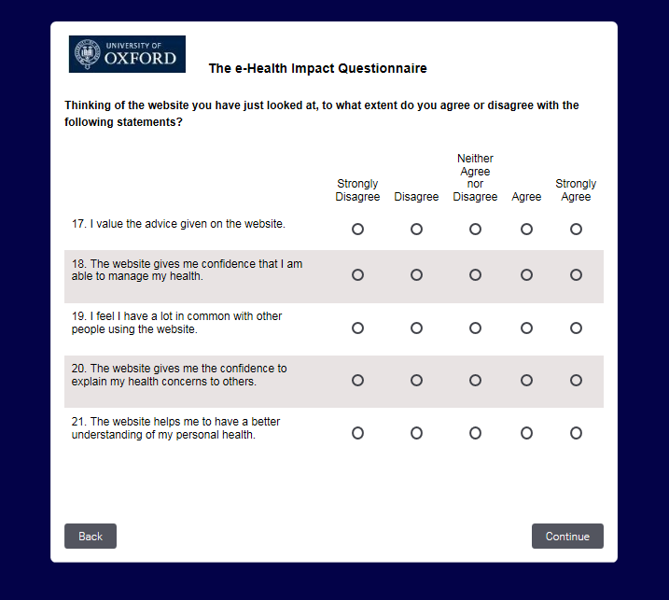

Page 8
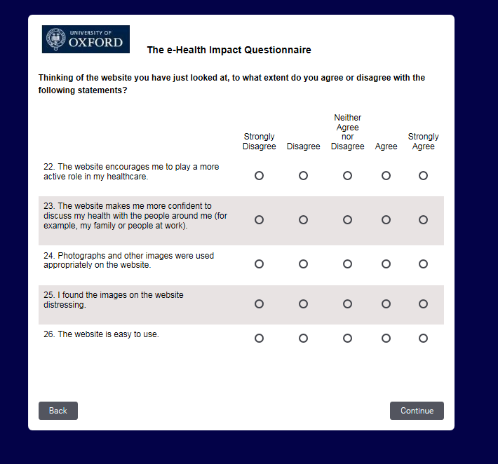

References

1. Ziebland, S. and S. Wyke, Health and illness in a connected world: how might seeing and sharing experiences on the internet affect people’s health? . The Milbank Quarterly, 2012. 90(2): p. 219-49.
2. Willis, G.B., Cognitive interviewing: a tool for improving questionnaire design2005, London: Sage Publications.
3. Willis, G.B., Cognitive Interviewing: A “How To” Guide, in Short course presented at the 1999 Meeting of the American Statistical Association1999, Research Triangle Institute.
4. Kelly, L., C. Jenkinson, and S. Ziebland, Measuring the effects of online health information for patients: Item generation for an e-health impact questionnaire. Patient Education and Counseling, 2013. 93(3): p. 433-438.
5. Norman, G. and D. Streiner, Biostatistics: The Bare Essentials Second ed2000, London: B.C. Decker.
6. Nunnally, J. and I.H. Bernstein, Psychometric Theory. 3rd ed1994: New York: McGraw-Hill.
7. Kelly, L., S. Ziebland, and C. Jenkinson, Measuring the effects of online health information: Scale validation for the e-Health Impact Questionnaire. Patient Education and Counseling, 2015. 22(15): p. 00281-5.
8. Gorsuch, R.L., Factor Analysis1983: L. Erlbaum Associates.

